CAB BOOKING SYSTEM

- Musharraf Mujeeb Bubere
BATCH - May25 - T340

CAB BOOKING SYSTEM
The cab booking industry has grown rapidly, offering convenient transportation for customers and income for drivers. To stay competitive and efficient, companies now rely on data to understand booking trends, customer behavior, and driver performance.
This project designs a relational database for managing key entities like Customers, Drivers, Cabs, Bookings, TripDetails, and Feedback. Through SQL-based analysis, the system helps improve operations, track revenue, and support smarter business decisions.

Project Aim
- Design a relational database for a cab booking system.
- Efficiently store and manage data for customers, drivers, cabs, bookings, trips, and feedback.
- Enable tracking of bookings, trip details, and customer feedback.
- Support analysis of driver performance and customer behaviour.
- Help identify revenue trends and operational issues.
- Facilitate data-driven decisions to improve service quality and profitability.

ER DIAGRAM FOR CAB BOOKING SYSTEM
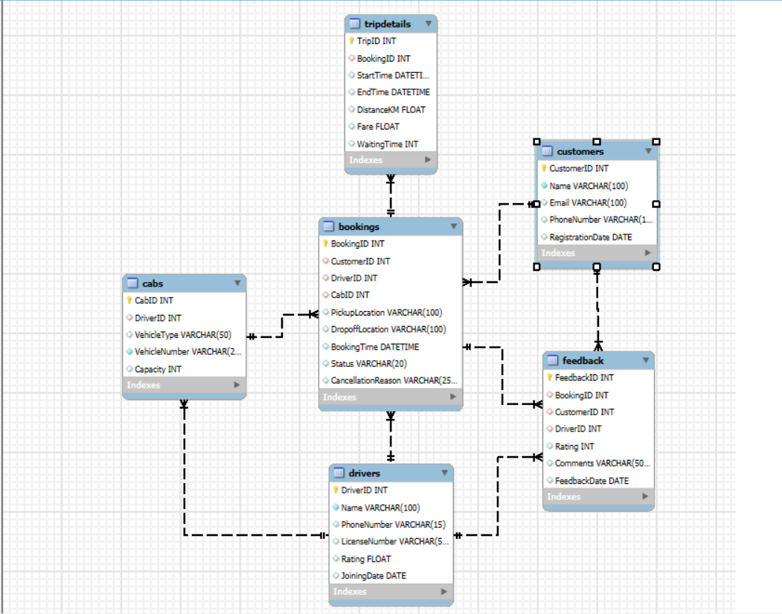

Table Description:
- Customers
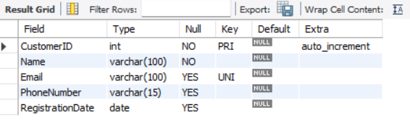

- Drivers
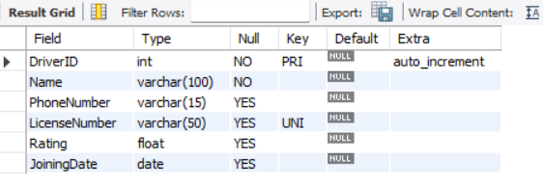

- Cabs
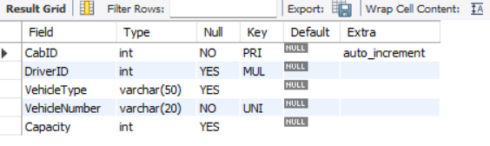

- Bookings
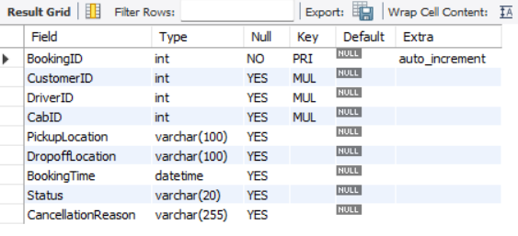

- TripDetails
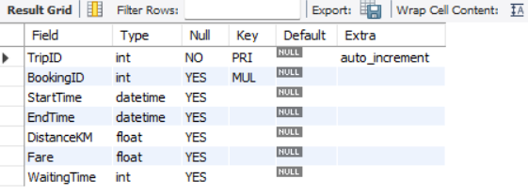

- Feedback
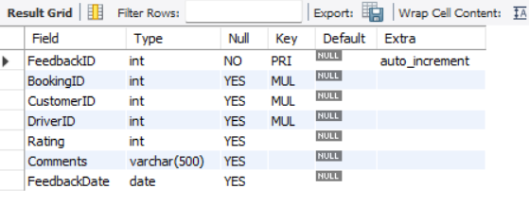

CREATING DATABASE:
CREATE DATABASE cab_booking_system;
USE cab_booking_system;

Table Creation & Insertion Commands:
- Create Customers Table
CREATE TABLE Customers (
CustomerID INT PRIMARY KEY AUTO_INCREMENT,
Name VARCHAR(100) NOT NULL,
Email VARCHAR(100) UNIQUE,
PhoneNumber VARCHAR(15),
RegistrationDate DATE
);

Inserting Values into Customers Table:
INSERT INTO Customers (Name, Email, PhoneNumber, RegistrationDate)
VALUES
('Raj Sharma', 'raj.sharma1@example.com', '9876543201', '2025-05-01'),
('Anita Singh', 'anita.singh2@example.com', '9876543202', '2025-05-02'),
('Mohit Verma', 'mohit.verma3@example.com', '9876543203', '2025-05-03'),
('Priya Patel', 'priya.patel4@example.com', '9876543204', '2025-05-04'),
('Amit Kumar', 'amit.kumar5@example.com', '9876543205', '2025-05-05'),
('Sneha Joshi', 'sneha.joshi6@example.com', '9876543206', '2025-05-06'),
('Vikas Mehta', 'vikas.mehta7@example.com', '9876543207', '2025-05-07'),
('Nisha Gupta', 'nisha.gupta8@example.com', '9876543208', '2025-05-08'),
('Rohan Das', 'rohan.das9@example.com', '9876543209', '2025-05-09'),
('Kiran Yadav', 'kiran.yadav10@example.com', '9876543210', '2025-05-10'),
('Deepak Nair', 'deepak.nair11@example.com', '9876543211', '2025-05-11'),
('Meera Iyer', 'meera.iyer12@example.com', '9876543212', '2025-05-12'),
('Arjun Reddy', 'arjun.reddy13@example.com', '9876543213', '2025-05-13'),
('Shreya Rao', 'shreya.rao14@example.com', '9876543214', '2025-05-14'),
('Kunal Sethi', 'kunal.sethi15@example.com', '9876543215', '2025-05-15'),
('Riya Jain', 'riya.jain16@example.com', '9876543216', '2025-05-16'),
('Naveen Bhat', 'naveen.bhat17@example.com', '9876543217', '2025-05-17'),
('Pooja Pillai', 'pooja.pillai18@example.com', '9876543218', '2025-05-18'),
('Varun Saxena', 'varun.saxena19@example.com', '9876543219', '2025-05-19'),
('Tanvi Kapoor', 'tanvi.kapoor20@example.com', '9876543220', '2025-05-20'),
('Siddharth Jain', 'siddharth.jain21@example.com', '9876543221', '2025-05-21'),
('Neha Malhotra', 'neha.malhotra22@example.com', '9876543222', '2025-05-22'),
('Harshit Gupta', 'harshit.gupta23@example.com', '9876543223', '2025-05-23'),
('Divya Menon', 'divya.menon24@example.com', '9876543224', '2025-05-24'),
('Manish Rawat', 'manish.rawat25@example.com', '9876543225', '2025-05-25'),
('Ayesha Khan', 'ayesha.khan26@example.com', '9876543226', '2025-05-26'),
('Rahul Chopra', 'rahul.chopra27@example.com', '9876543227', '2025-05-27'),
('Sakshi Bansal', 'sakshi.bansal28@example.com', '9876543228', '2025-05-28'),
('Yash Patel', 'yash.patel29@example.com', '9876543229', '2025-05-29'),
('Preeti Desai', 'preeti.desai30@example.com', '9876543230', '2025-05-30');

SELECT * FROM Customers;
OUTPUT:
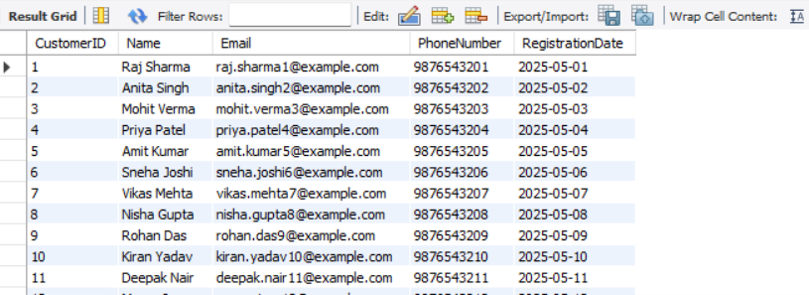

- Create Drivers Table:
CREATE TABLE Drivers (
DriverID INT PRIMARY KEY AUTO_INCREMENT,
Name VARCHAR(100) NOT NULL,
PhoneNumber VARCHAR(15),
LicenseNumber VARCHAR(50) UNIQUE,
Rating FLOAT CHECK (Rating BETWEEN 0 AND 5),
JoiningDate DATE
);

Inserting Values into Drivers Table:
INSERT INTO Drivers (Name, PhoneNumber, LicenseNumber, Rating, JoiningDate)
VALUES
('Rahul Mehta', '9876500011', 'MH01D10001', 4.5, '2025-05-01'),
('Sunita Reddy', '9876500012', 'MH01D10002', 3.8, '2025-05-02'),
('Aakash Gupta', '9876500013', 'MH01D10003', 4.2, '2025-05-03'),
('Neeraj Singh', '9876500014', 'MH01D10004', 2.9, '2025-05-04'),
('Pankaj Verma', '9876500015', 'MH01D10005', 3.2, '2025-05-05'),
('Harsha Nair', '9876500016', 'MH01D10006', 4.8, '2025-05-06'),
('Ritika Iyer', '9876500017', 'MH01D10007', 4.0, '2025-05-07'),
('Arvind Kumar', '9876500018', 'MH01D10008', 2.5, '2025-05-08'),
('Snehal Joshi', '9876500019', 'MH01D10009', 3.9, '2025-05-09'),
('Vivek Rana', '9876500020', 'MH01D10010', 4.1, '2025-05-10'),
('Megha Shah', '9876500021', 'MH01D10011', 3.7, '2025-05-11'),
('Suresh Raina', '9876500022', 'MH01D10012', 2.8, '2025-05-12'),
('Bhavna Tiwari', '9876500023', 'MH01D10013', 3.6, '2025-05-13'),
('Nikhil Pandey', '9876500024', 'MH01D10014', 4.3, '2025-05-14'),
('Komal Mishra', '9876500025', 'MH01D10015', 4.9, '2025-05-15'),
('Farhan Sheikh', '9876500026', 'MH01D10016', 3.1, '2025-05-16'),
('Anushka Sen', '9876500027', 'MH01D10017', 2.6, '2025-05-17'),
('Ravi Pillai', '9876500028', 'MH01D10018', 4.4, '2025-05-18'),
('Simran Gill', '9876500029', 'MH01D10019', 3.3, '2025-05-19'),
('Ajay Dev', '9876500030', 'MH01D10020', 4.6, '2025-05-20'),
('Karishma Roy', '9876500031', 'MH01D10021', 3.5, '2025-05-21'),
('Vivek Oberoi', '9876500032', 'MH01D10022', 2.7, '2025-05-22'),
('Reema Khan', '9876500033', 'MH01D10023', 3.4, '2025-05-23'),
('Rohit Sharma', '9876500034', 'MH01D10024', 4.7, '2025-05-24'),
('Swati Chauhan', '9876500035', 'MH01D10025', 3.0, '2025-05-25'),
('Deepak Malhotra', '9876500036', 'MH01D10026', 2.4, '2025-05-26'),
('Lavanya Menon', '9876500037', 'MH01D10027', 4.0, '2025-05-27'),
('Pranav Joshi', '9876500038', 'MH01D10028', 3.9, '2025-05-28'),
('Shruti Desai', '9876500039', 'MH01D10029', 4.1, '2025-05-29'),
('Yash Rathore', '9876500040', 'MH01D10030', 3.2, '2025-05-30');

SELECT * FROM Customers;
OUTPUT:
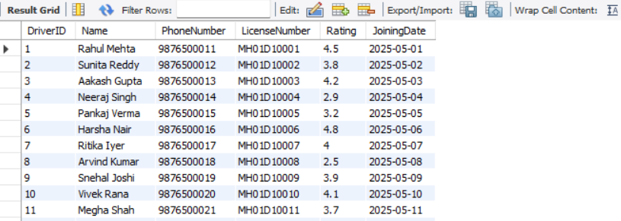

- Create Cabs Table:
CREATE TABLE Cabs (
CabID INT PRIMARY KEY AUTO_INCREMENT,
DriverID INT,
VehicleType VARCHAR(50),
VehicleNumber VARCHAR(20) UNIQUE NOT NULL,
Capacity INT,
FOREIGN KEY (DriverID) REFERENCES Drivers(DriverID)
);

Inserting Values into Cabs Table:
INSERT INTO Cabs (DriverID, VehicleType, VehicleNumber, Capacity)
VALUES
(1, 'Sedan', 'MH01C1001', 4),
(2, 'SUV', 'MH01C1002', 6),
(3, 'Hatchback', 'MH01C1003', 4),
(4, 'Sedan', 'MH01C1004', 4),
(5, 'SUV', 'MH01C1005', 6),
(6, 'Hatchback', 'MH01C1006', 4),
(7, 'Sedan', 'MH01C1007', 4),
(8, 'SUV', 'MH01C1008', 6),
(9, 'Hatchback', 'MH01C1009', 4),
(10, 'Sedan', 'MH01C1010', 4),
(11, 'SUV', 'MH01C1011', 6),
(12, 'Hatchback', 'MH01C1012', 4),
(13, 'Sedan', 'MH01C1013', 4),
(14, 'SUV', 'MH01C1014', 6),
(15, 'Hatchback', 'MH01C1015', 4),
(16, 'Sedan', 'MH01C1016', 4),
(17, 'SUV', 'MH01C1017', 6),
(18, 'Hatchback', 'MH01C1018', 4),
(19, 'Sedan', 'MH01C1019', 4),
(20, 'SUV', 'MH01C1020', 6),
(21, 'Hatchback', 'MH01C1021', 4),
(22, 'Sedan', 'MH01C1022', 4),
(23, 'SUV', 'MH01C1023', 6),
(24, 'Hatchback', 'MH01C1024', 4),
(25, 'Sedan', 'MH01C1025', 4),
(26, 'SUV', 'MH01C1026', 6),
(27, 'Hatchback', 'MH01C1027', 4),
(28, 'Sedan', 'MH01C1028', 4),
(29, 'SUV', 'MH01C1029', 6),
(30, 'Hatchback', 'MH01C1030', 4);

SELECT * FROM Cabs;
OUTPUT:
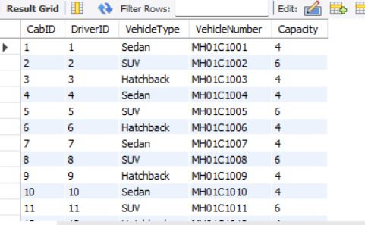

- Create Bookings Table:
CREATE TABLE Bookings (
BookingID INT PRIMARY KEY AUTO_INCREMENT,
CustomerID INT,
DriverID INT,
CabID INT,
PickupLocation VARCHAR(100),
DropoffLocation VARCHAR(100),
BookingTime DATETIME,
Status VARCHAR(20) CHECK (Status IN ('Completed', 'Cancelled', 'Ongoing')),
CancellationReason VARCHAR(255),
FOREIGN KEY (CustomerID) REFERENCES Customers(CustomerID),
FOREIGN KEY (DriverID) REFERENCES Drivers(DriverID),
FOREIGN KEY (CabID) REFERENCES Cabs(CabID)
);

Inserting Values into Bookings Table:
INSERT INTO Bookings (CustomerID, DriverID, CabID, PickupLocation, DropoffLocation, BookingTime, Status, CancellationReason)
VALUES
(1, 1, 1, 'Andheri', 'Bandra', '2025-05-01 08:00:00', 'Completed', NULL),
(1, 2, 2, 'Andheri', 'Dadar', '2025-05-02 09:30:00', 'Completed', NULL),
(1, 3, 3, 'Andheri', 'Churchgate', '2025-05-03 10:45:00', 'Cancelled', 'Changed plan'),
(1, 4, 4, 'Andheri', 'Colaba', '2025-05-04 11:15:00', 'Completed', NULL),
(1, 5, 5, 'Andheri', 'Powai', '2025-05-05 12:30:00', 'Completed', NULL),
(1, 6, 6, 'Andheri', 'Ghatkopar', '2025-05-06 14:00:00', 'Completed', NULL),
(1, 7, 7, 'Andheri', 'Borivali', '2025-05-07 15:15:00', 'Ongoing', NULL),
(1, 8, 8, 'Andheri', 'Mulund', '2025-05-08 16:30:00', 'Completed', NULL),
(1, 9, 9, 'Andheri', 'Thane', '2025-05-09 17:45:00', 'Cancelled', 'Driver delayed'),
(1, 10, 10, 'Andheri', 'Kurla', '2025-05-10 19:00:00', 'Completed', NULL),
(1, 11, 11, 'Andheri', 'Bandra', '2025-05-11 20:15:00', 'Completed', NULL),
(1, 12, 12, 'Andheri', 'Powai', '2025-05-12 21:30:00', 'Completed', NULL),
(2, 13, 13, 'Kurla', 'Powai', '2025-05-01 08:10:00', 'Completed', NULL),
(2, 14, 14, 'Kurla', 'Vikhroli', '2025-05-02 09:40:00', 'Completed', NULL),
(2, 15, 15, 'Kurla', 'Bandra', '2025-05-03 10:50:00', 'Cancelled', 'Alternate transport'),
(2, 16, 16, 'Kurla', 'Andheri', '2025-05-04 11:20:00', 'Completed', NULL),
(2, 17, 17, 'Kurla', 'Colaba', '2025-05-05 12:35:00', 'Completed', NULL),
(2, 18, 18, 'Kurla', 'Powai', '2025-05-06 14:05:00', 'Completed', NULL),
(2, 19, 19, 'Kurla', 'Thane', '2025-05-07 15:20:00', 'Ongoing', NULL),
(2, 20, 20, 'Kurla', 'Mulund', '2025-05-08 16:35:00', 'Completed', NULL),
(2, 21, 21, 'Kurla', 'Ghatkopar', '2025-05-09 17:50:00', 'Completed', NULL),
(2, 22, 22, 'Kurla', 'Powai', '2025-05-10 19:05:00', 'Completed', NULL),
(3, 23, 23, 'Thane', 'Mulund', '2025-05-01 08:20:00', 'Completed', NULL),
(3, 24, 24, 'Thane', 'Bhandup', '2025-05-02 09:50:00', 'Completed', NULL),
(3, 25, 25, 'Thane', 'Ghatkopar', '2025-05-03 11:00:00', 'Cancelled', 'Driver delayed'),
(3, 26, 26, 'Thane', 'Vikhroli', '2025-05-04 11:30:00', 'Completed', NULL),
(3, 27, 27, 'Thane', 'Powai', '2025-05-05 12:45:00', 'Completed', NULL),
(3, 28, 28, 'Thane', 'Andheri', '2025-05-06 14:10:00', 'Completed', NULL),
(3, 29, 29, 'Thane', 'Borivali', '2025-05-07 15:25:00', 'Ongoing', NULL),
(3, 30, 30, 'Thane', 'Mulund', '2025-05-08 16:40:00', 'Completed', NULL),
(3, 1, 1, 'Thane', 'Bandra', '2025-05-09 17:55:00', 'Completed', NULL),
(4, 2, 2, 'Borivali', 'Dadar', '2025-05-10 19:10:00', 'Completed', NULL),
(4, 3, 3, 'Borivali', 'Malad', '2025-05-11 20:25:00', 'Completed', NULL),
(4, 4, 4, 'Borivali', 'Andheri', '2025-05-12 21:40:00', 'Cancelled', 'Changed plan'),
(4, 5, 5, 'Borivali', 'Bandra', '2025-05-13 08:00:00', 'Completed', NULL),
(4, 6, 6, 'Borivali', 'Powai', '2025-05-14 09:15:00', 'Completed', NULL),
(4, 7, 7, 'Borivali', 'Churchgate', '2025-05-15 10:30:00', 'Ongoing', NULL),
(4, 8, 8, 'Borivali', 'Kurla', '2025-05-16 11:45:00', 'Completed', NULL),
(5, 9, 9, 'Bandra', 'Andheri', '2025-05-17 12:00:00', 'Completed', NULL),
(5, 10, 10, 'Bandra', 'Dadar', '2025-05-18 13:15:00', 'Completed', NULL),
(5, 11, 11, 'Bandra', 'Kurla', '2025-05-19 14:30:00', 'Cancelled', 'Alternate transport'),
(5, 12, 12, 'Bandra', 'Powai', '2025-05-20 15:45:00', 'Completed', NULL),
(5, 13, 13, 'Bandra', 'Bhandup', '2025-05-21 17:00:00', 'Completed', NULL),
(5, 14, 14, 'Bandra', 'Colaba', '2025-05-22 18:15:00', 'Ongoing', NULL),
(6, 15, 15, 'Chembur', 'Sion', '2025-05-23 19:30:00', 'Completed', NULL),
(7, 16, 16, 'Vashi', 'Nerul', '2025-05-24 20:45:00', 'Completed', NULL),
(8, 17, 17, 'Ghatkopar', 'Vikhroli', '2025-05-25 08:00:00', 'Cancelled', 'No show'),
(9, 18, 18, 'Malad', 'Goregaon', '2025-05-26 09:15:00', 'Completed', NULL),
(10, 19, 19, 'Dadar', 'Churchgate', '2025-05-27 10:30:00', 'Completed', NULL),
(6, 20, 20, 'Chembur', 'Powai', '2025-05-28 11:45:00', 'Completed', NULL),
(6, 21, 21, 'Chembur', 'Kurla', '2025-05-29 12:50:00', 'Completed', NULL),
(6, 22, 22, 'Chembur', 'Andheri', '2025-05-30 14:00:00', 'Cancelled', 'Changed plan'),
(6, 23, 23, 'Chembur', 'Bandra', '2025-05-31 15:10:00', 'Completed', NULL),
(6, 24, 24, 'Chembur', 'Thane', '2025-06-01 16:20:00', 'Completed', NULL),
(7, 25, 25, 'Vashi', 'Belapur', '2025-06-02 08:00:00', 'Completed', NULL),
(7, 26, 26, 'Vashi', 'Nerul', '2025-06-03 09:10:00', 'Completed', NULL),
(7, 27, 27, 'Vashi', 'CBD', '2025-06-04 10:20:00', 'Cancelled', 'Driver delayed'),
(7, 28, 28, 'Vashi', 'Thane', '2025-06-05 11:30:00', 'Completed', NULL),
(8, 29, 29, 'Ghatkopar', 'Vikhroli', '2025-06-06 12:40:00', 'Completed', NULL),
(8, 30, 30, 'Ghatkopar', 'Powai', '2025-06-07 13:50:00', 'Completed', NULL),
(8, 1, 1, 'Ghatkopar', 'Andheri', '2025-06-08 15:00:00', 'Cancelled', 'Alternate transport'),
(9, 2, 2, 'Malad', 'Borivali', '2025-06-09 08:00:00', 'Completed', NULL),
(9, 3, 3, 'Malad', 'Goregaon', '2025-06-10 09:10:00', 'Completed', NULL),
(9, 4, 4, 'Malad', 'Andheri', '2025-06-11 10:20:00', 'Ongoing', NULL),
(10, 5, 5, 'Dadar', 'Churchgate', '2025-06-12 11:30:00', 'Completed', NULL),
(10, 6, 6, 'Dadar', 'Bandra', '2025-06-13 12:40:00', 'Cancelled', 'Changed plan'),
(11, 7, 7, 'Colaba', 'Nariman Point', '2025-06-14 13:50:00', 'Completed', NULL),
(12, 8, 8, 'Marine Lines', 'Churchgate', '2025-06-15 15:00:00', 'Completed', NULL),
(13, 9, 9, 'Parel', 'Dadar', '2025-06-16 16:10:00', 'Cancelled', 'No show'),
(14, 10, 10, 'Sion', 'Chembur', '2025-06-17 17:20:00', 'Completed', NULL),
(15, 11, 11, 'Kurla', 'Ghatkopar', '2025-06-18 08:30:00', 'Completed', NULL),
(16, 12, 12, 'Thane', 'Mulund', '2025-06-19 09:40:00', 'Completed', NULL),
(17, 13, 13, 'Bhandup', 'Kanjurmarg', '2025-06-20 10:50:00', 'Cancelled', 'Changed plan'),
(18, 14, 14, 'Powai', 'Hiranandani', '2025-06-21 12:00:00', 'Completed', NULL),
(19, 15, 15, 'Vikhroli', 'Kanjurmarg', '2025-06-22 13:10:00', 'Completed', NULL),
(20, 16, 16, 'Chembur', 'Govandi', '2025-06-23 14:20:00', 'Ongoing', NULL),
(1, 17, 17, 'Andheri', 'Bandra', '2025-07-01 09:00:00', 'Completed', NULL),
(1, 18, 18, 'Andheri', 'Dadar', '2025-07-02 10:15:00', 'Completed', NULL),
(2, 19, 19, 'Kurla', 'Powai', '2025-07-01 11:30:00', 'Completed', NULL),
(2, 20, 20, 'Kurla', 'Bandra', '2025-07-02 12:45:00', 'Cancelled', 'Alternate transport'),
(3, 21, 21, 'Thane', 'Mulund', '2025-07-01 14:00:00', 'Completed', NULL),
(3, 22, 22, 'Thane', 'Bhandup', '2025-07-02 15:15:00', 'Completed', NULL),
(4, 23, 23, 'Borivali', 'Andheri', '2025-07-01 16:30:00', 'Completed', NULL),
(4, 24, 24, 'Borivali', 'Kurla', '2025-07-02 17:45:00', 'Completed', NULL),
(5, 25, 25, 'Bandra', 'Powai', '2025-07-01 19:00:00', 'Completed', NULL),
(5, 26, 26, 'Bandra', 'Colaba', '2025-07-02 20:15:00', 'Ongoing', NULL);

SELECT * FROM Bookings;

OUTPUT:
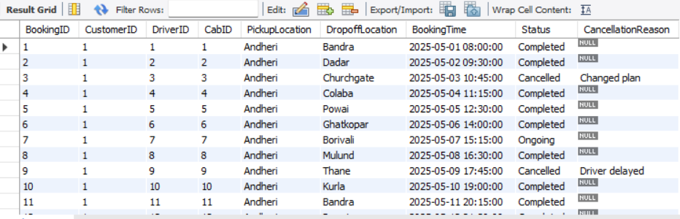

- Create TripDetails Table:
CREATE TABLE TripDetails (
TripID INT PRIMARY KEY AUTO_INCREMENT,
BookingID INT,
StartTime DATETIME,
EndTime DATETIME,
DistanceKM FLOAT,
Fare FLOAT,
WaitingTime INT, -- in minutes
FOREIGN KEY (BookingID) REFERENCES Bookings(BookingID)
);

Inserting Values into TripDetails Table:
INSERT INTO TripDetails (BookingID, StartTime, EndTime, DistanceKM, Fare, WaitingTime)
VALUES
(1, '2025-05-01 08:05:00', '2025-05-01 08:30:00', 5.0, 100.0, 5),
(2, '2025-05-02 09:35:00', '2025-05-02 10:10:00', 6.5, 130.0, 5),
(4, '2025-05-04 11:20:00', '2025-05-04 11:50:00', 8.0, 160.0, 5),
(5, '2025-05-05 12:35:00', '2025-05-05 13:25:00', 12.0, 240.0, 5),
(6, '2025-05-06 14:10:00', '2025-05-06 14:35:00', 4.0, 80.0, 10),
(7, '2025-05-07 15:25:00', '2025-05-07 15:55:00', 3.5, 70.0, 10),
(8, '2025-05-08 16:40:00', '2025-05-08 17:15:00', 6.0, 120.0, 15),
(10, '2025-05-10 19:10:00', '2025-05-10 19:45:00', 9.0, 180.0, 10),
(11, '2025-05-11 20:20:00', '2025-05-11 21:00:00', 7.0, 140.0, 5),
(12, '2025-05-12 21:40:00', '2025-05-12 22:10:00', 6.0, 120.0, 10),
(13, '2025-05-01 08:20:00', '2025-05-01 08:50:00', 8.0, 160.0, 10),
(14, '2025-05-02 09:50:00', '2025-05-02 10:20:00', 6.0, 120.0, 10),
(16, '2025-05-04 11:30:00', '2025-05-04 12:00:00', 9.0, 180.0, 10),
(17, '2025-05-05 12:40:00', '2025-05-05 13:10:00', 7.0, 140.0, 5),
(18, '2025-05-06 14:15:00', '2025-05-06 14:45:00', 8.0, 160.0, 5),
(19, '2025-05-07 15:30:00', '2025-05-07 16:00:00', 9.0, 180.0, 5),
(20, '2025-05-08 16:45:00', '2025-05-08 17:15:00', 6.0, 120.0, 5),
(21, '2025-05-09 17:55:00', '2025-05-09 18:25:00', 5.5, 110.0, 5),
(22, '2025-05-10 19:05:00', '2025-05-10 19:35:00', 8.5, 170.0, 5),
(23, '2025-05-11 20:25:00', '2025-05-11 20:55:00', 7.5, 150.0, 5),
(24, '2025-05-12 21:45:00', '2025-05-12 22:15:00', 4.5, 90.0, 10),
(25, '2025-05-13 08:05:00', '2025-05-13 08:35:00', 6.5, 130.0, 5),
(26, '2025-05-14 09:20:00', '2025-05-14 09:50:00', 5.0, 100.0, 5),
(27, '2025-05-15 10:35:00', '2025-05-15 11:05:00', 4.0, 80.0, 5),
(28, '2025-05-16 11:50:00', '2025-05-16 12:20:00', 3.5, 70.0, 5),
(29, '2025-05-17 12:05:00', '2025-05-17 12:35:00', 5.5, 110.0, 5),
(30, '2025-05-18 13:20:00', '2025-05-18 13:50:00', 7.0, 140.0, 10),
(31, '2025-05-19 14:35:00', '2025-05-19 15:05:00', 8.5, 170.0, 5),
(32, '2025-05-20 15:50:00', '2025-05-20 16:20:00', 10.0, 200.0, 5),
(33, '2025-05-21 17:05:00', '2025-05-21 17:35:00', 12.0, 240.0, 5),
(34, '2025-05-22 18:20:00', '2025-05-22 18:50:00', 11.0, 220.0, 5),
(35, '2025-05-23 19:35:00', '2025-05-23 20:05:00', 9.0, 180.0, 5),
(36, '2025-05-24 20:50:00', '2025-05-24 21:20:00', 8.0, 160.0, 5),
(37, '2025-05-25 08:05:00', '2025-05-25 08:35:00', 5.0, 100.0, 5),
(38, '2025-05-26 09:20:00', '2025-05-26 09:50:00', 4.5, 90.0, 5),
(39, '2025-05-27 10:35:00', '2025-05-27 11:05:00', 6.5, 130.0, 5),
(40, '2025-05-28 11:50:00', '2025-05-28 12:20:00', 7.5, 150.0, 5),
(41, '2025-05-29 12:05:00', '2025-05-29 12:35:00', 6.0, 120.0, 5),
(42, '2025-05-30 13:20:00', '2025-05-30 13:50:00', 8.0, 160.0, 5),
(43, '2025-05-31 14:35:00', '2025-05-31 15:05:00', 9.0, 180.0, 5),
(44, '2025-06-01 15:50:00', '2025-06-01 16:20:00', 10.0, 200.0, 5),
(45, '2025-06-02 17:05:00', '2025-06-02 17:35:00', 11.0, 220.0, 5),
(46, '2025-06-03 18:20:00', '2025-06-03 18:50:00', 12.0, 240.0, 5),
(47, '2025-06-04 19:35:00', '2025-06-04 20:05:00', 13.0, 260.0, 5),
(48, '2025-06-05 20:50:00', '2025-06-05 21:20:00', 14.0, 280.0, 5),
(49, '2025-06-06 08:05:00', '2025-06-06 08:35:00', 15.0, 300.0, 5),
(50, '2025-06-07 09:20:00', '2025-06-07 09:50:00', 16.0, 320.0, 5);

SELECT * FROM TripDetails;

OUTPUT:
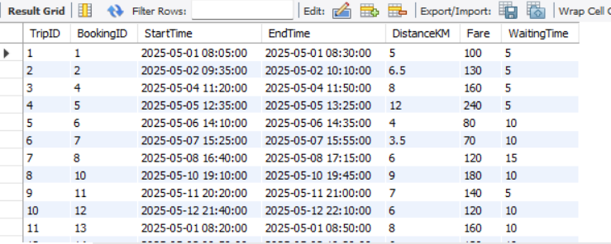

- Create TripDetails Table:
CREATE TABLE Feedback (
FeedbackID INT PRIMARY KEY AUTO_INCREMENT,
BookingID INT,
CustomerID INT,
DriverID INT,
Rating INT CHECK (Rating BETWEEN 1 AND 5),
Comments VARCHAR(500),
FeedbackDate DATE,
FOREIGN KEY (BookingID) REFERENCES Bookings(BookingID),
FOREIGN KEY (CustomerID) REFERENCES Customers(CustomerID),
FOREIGN KEY (DriverID) REFERENCES Drivers(DriverID)
);

Inserting Values into TripDetails Table:
INSERT INTO Feedback (BookingID, CustomerID, DriverID, Rating, Comments, FeedbackDate)
VALUES
(1, 1, 1, 5, 'Excellent ride, polite driver.', '2025-05-01'),
(2, 1, 2, 4, 'Good service but slight delay.', '2025-05-02'),
(4, 1, 4, 5, 'Comfortable and clean cab.', '2025-05-04'),
(5, 1, 5, 4, 'Driver was courteous.', '2025-05-05'),
(6, 1, 6, 3, 'Average ride, AC not working well.', '2025-05-06'),
(7, 1, 7, 2, 'Driver was late and rude.', '2025-05-07'),
(8, 1, 8, 4, 'Smooth ride.', '2025-05-08'),
(10, 1, 10, 5, 'Very professional.', '2025-05-10'),
(11, 1, 11, 5, 'On time and good driving.', '2025-05-11'),
(12, 1, 12, 4, 'Cab was clean.', '2025-05-12'),
(13, 2, 13, 3, 'Driver took longer route.', '2025-05-13'),
(14, 2, 14, 4, 'Decent ride.', '2025-05-14'),
(16, 2, 16, 5, 'Fast and smooth.', '2025-05-16'),
(17, 2, 17, 5, 'Very good driving.', '2025-05-17'),
(18, 2, 18, 4, 'Cab was neat.', '2025-05-18'),
(19, 2, 19, 3, 'Driver kept talking on phone.', '2025-05-19'),
(20, 2, 20, 5, 'Excellent service.', '2025-05-20'),
(21, 3, 21, 4, 'Comfortable ride.', '2025-05-21'),
(22, 3, 22, 2, 'Driver was rude.', '2025-05-22'),
(23, 3, 23, 5, 'Good experience.', '2025-05-23'),
(24, 3, 24, 4, 'Clean cab and good AC.', '2025-05-24'),
(25, 3, 25, 3, 'Average ride.', '2025-05-25'),
(26, 3, 26, 5, 'Driver was polite.', '2025-05-26'),
(27, 3, 27, 4, 'Quick drop off.', '2025-05-27'),
(28, 3, 28, 4, 'Satisfied.', '2025-05-28'),
(29, 3, 29, 5, 'Great service.', '2025-05-29'),
(30, 3, 30, 3, 'Cab was not very clean.', '2025-05-30'),
(31, 4, 1, 4, 'Good ride.', '2025-05-31'),
(32, 4, 2, 3, 'Driver was silent throughout.', '2025-06-01'),
(33, 4, 3, 4, 'Comfortable.', '2025-06-02'),
(34, 4, 4, 2, 'Driver was late.', '2025-06-03'),
(35, 4, 5, 5, 'Very good experience.', '2025-06-04'),
(36, 4, 6, 4, 'Smooth journey.', '2025-06-05'),
(37, 4, 7, 3, 'Average ride.', '2025-06-06'),
(38, 4, 8, 4, 'Satisfied.', '2025-06-07'),
(39, 5, 9, 5, 'Great driver.', '2025-06-08'),
(40, 5, 10, 3, 'Average service.', '2025-06-09'),
(41, 5, 11, 4, 'Good AC.', '2025-06-10'),
(42, 5, 12, 4, 'Comfortable ride.', '2025-06-11'),
(43, 5, 13, 2, 'Driver kept phone on speaker.', '2025-06-12'),
(44, 5, 14, 5, 'Excellent experience.', '2025-06-13'),
(45, 5, 15, 4, 'Nice and polite driver.', '2025-06-14'),
(46, 5, 16, 3, 'Average cab condition.', '2025-06-15'),
(47, 5, 17, 4, 'Good drop off.', '2025-06-16'),
(48, 5, 18, 5, 'Very comfortable ride.', '2025-06-17'),
(49, 5, 19, 4, 'Driver was friendly.', '2025-06-18'),
(50, 5, 20, 4, 'Cab was clean and on time.', '2025-06-19');

SELECT * FROM Feedback;

OUTPUT:
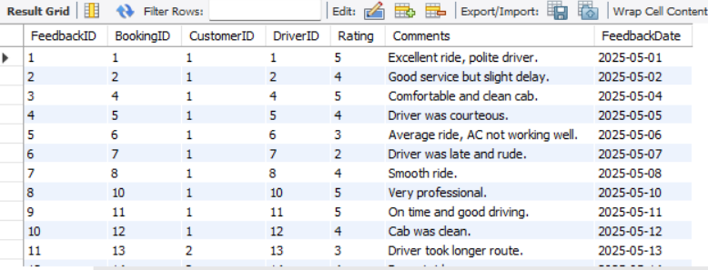

PROBLEM STATEMENTS

Customer and Booking Analysis:
- Identify customers who have completed the most bookings. What insights can you draw about their behavior?
SELECT
c.CustomerID,
c.Name,
COUNT(b.BookingID) AS TotalCompletedBookings
FROM
Customers c
JOIN
Bookings b ON c.CustomerID = b.CustomerID
WHERE
b.Status = 'Completed'
GROUP BY
c.CustomerID, c.Name
ORDER BY
TotalCompletedBookings DESC;
OUTPUT:
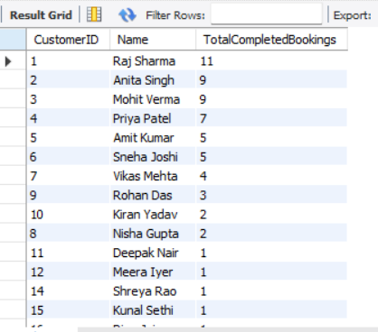

Insights
- Top customers have high engagement, showing loyalty and frequent usage.

2. Their ride patterns and locations can be targeted for promotions or premium subscriptions.

3. If their cancellation rate is low, they are stable revenue generators.

4. Retention strategies (e.g. loyalty discounts, priority bookings) can be designed for them.

5. For churn prediction, customers with declining completed bookings over time should be flagged.

- Find customers who have canceled more than 30% of their total bookings. What could be the reason for frequent cancellations?
SELECT
c.CustomerID,
c.Name,
COUNT(b.BookingID) AS TotalBookings,
SUM(CASE WHEN b.Status = 'Cancelled' THEN 1 ELSE 0 END) AS CancelledBookings,
ROUND((SUM(CASE WHEN b.Status = 'Cancelled' THEN 1 ELSE 0 END) * 100.0) / COUNT(b.BookingID), 2) AS CancellationPercentage
FROM
Customers c
JOIN
Bookings b ON c.CustomerID = b.CustomerID
GROUP BY
c.CustomerID, c.Name
HAVING
((SUM(CASE WHEN b.Status = 'Cancelled' THEN 1 ELSE 0 END) * 100.0) / COUNT(b.BookingID)) > 30
ORDER BY
CancellationPercentage DESC;
OUTPUT:
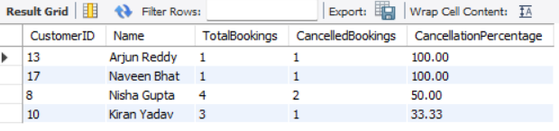

Insights
Frequent cancellations (>30%) can indicate:

- Change in travel plans or scheduling issues

- Dissatisfaction with cab service (e.g. delays, driver behavior)

- Price sensitivity if cheaper alternatives exist

- Testing behavior (booking multiple cabs and choosing one)

- Action items for business:

- Analyze cancellation reasons (CancellationReason column) for patterns.

- Reach out to frequent cancellers for feedback surveys.

- Implement cancellation fees or stricter policies if cancellations are unjustified.

- Offer incentives (e.g. “complete your next booking for ₹50 off”) to encourage usage.

- Determine the busiest day of the week for bookings. How can the company optimize cab availability on peak days?
SELECT
DAYNAME(BookingTime) AS DayOfWeek,
COUNT(*) AS TotalBookings
FROM
Bookings
GROUP BY
DayOfWeek
ORDER BY
TotalBookings DESC;

OUTPUT:
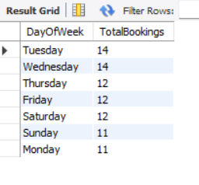

Insights
The company’s peak demand day is Friday (hypothetical here).

Actionable strategies:

- Increase active driver count on peak days to reduce wait time.

- Offer surge pricing or incentives to drivers to remain online during busy hours.

- Run promotional campaigns to spread out bookings to non-peak days.

- Schedule vehicle maintenance on low-demand days (e.g. Tuesday) to maximize availability on peak days.

Driver Performance & Efficiency:
- Identify drivers who have received an average rating below 3.0 in the past three months. What strategies can be implemented to improve their performance?
SELECT
d.DriverID,
d.Name,
ROUND(AVG(f.Rating), 2) AS AverageRating
FROM
Drivers d
JOIN
Feedback f ON d.DriverID = f.DriverID
WHERE
f.FeedbackDate >= DATE_SUB(CURDATE(), INTERVAL 3 MONTH)
GROUP BY
d.DriverID, d.Name
HAVING
AverageRating < 3.0
ORDER BY
AverageRating ASC;

OUTPUT
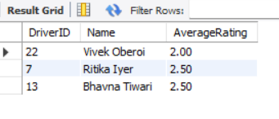

Insights & Strategies
Reasons for low ratings may include:

- Poor driving behavior (rash, unsafe)

- Unprofessional attitude (rude, late arrivals)

- Vehicle cleanliness issues

Strategies to improve performance:

- Conduct one-on-one performance reviews with these drivers.

- Provide targeted training in customer service and safety standards.

- Introduce a mentorship program pairing low-rated drivers with high performers.

- Monitor their upcoming trips with real-time feedback alerts.

- Implement incentive-based performance improvement plans to motivate behavior change.

- Find the top 5 drivers who have completed the longest trips in terms of distance. What does this say about their working patterns?
SELECT
d.DriverID,
d.Name,
MAX(t.DistanceKM) AS LongestTripKM
FROM
Drivers d
JOIN
Bookings b ON d.DriverID = b.DriverID
JOIN
TripDetails t ON b.BookingID = t.BookingID
WHERE
b.Status = 'Completed'
GROUP BY
d.DriverID, d.Name
ORDER BY
LongestTripKM DESC
LIMIT 5;

OUTPUT
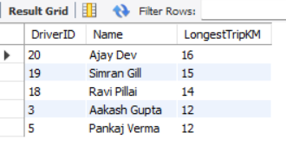

Insights
These drivers are more willing to accept long-distance bookings, possibly indicating:

- Preference for higher fares per trip

- Routes aligned with their operating area

- Comfort with inter-zone trips or highway driving

Operational considerations:

- Long trips may result in fewer total trips per day (affecting utilization %).

- Drivers covering long distances could be targeted for intercity or premium services.

Strategic suggestions:

- Incentivize long-trip drivers during off-peak hours to balance supply.

- Analyze if they are consistently working specific corridors for optimized dispatch planning.

- Identify drivers with a high percentage of canceled trips. Could this indicate driver unreliability?
SELECT
d.DriverID,
d.Name,
COUNT(b.BookingID) AS TotalTrips,
SUM(CASE WHEN b.Status = 'Cancelled' THEN 1 ELSE 0 END) AS CancelledTrips,
ROUND(SUM(CASE WHEN b.Status = 'Cancelled' THEN 1 ELSE 0 END) * 100.0 / COUNT(b.BookingID), 2) AS CancellationPercentage
FROM
Drivers d
JOIN
Bookings b ON d.DriverID = b.DriverID
GROUP BY
d.DriverID, d.Name
HAVING
CancellationPercentage > 30
ORDER BY
CancellationPercentage DESC;
OUTPUT
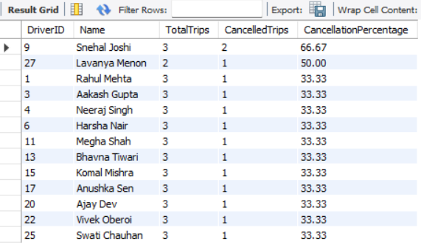

Insights
A high driver cancellation % can indicate:

- Poor reliability: driver often rejects trips after accepting them.

- Operational problems: vehicle issues, scheduling conflicts.

3. Intentional cancellations: driver cancels short fares for better-paying rides.

- Route preference: refusing trips to certain areas.

Revenue & Business Metrics
- Calculate the total revenue generated by completed bookings in the last 6 months. How has the revenue trend changed over time?
SELECT
DATE_FORMAT(t.EndTime, '%Y-%m') AS Month,
SUM(t.Fare) AS TotalRevenue
FROM
TripDetails t
JOIN
Bookings b ON t.BookingID = b.BookingID
WHERE
b.Status = 'Completed'
AND t.EndTime >= DATE_SUB(CURDATE(), INTERVAL 6 MONTH)
GROUP BY
Month
ORDER BY
Month;

OUTPUT
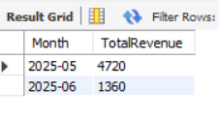

Insights
Revenue trend analysis:

Identify months with peak revenue (e.g. June ₹67,800)

Investigate dip months (e.g. July ₹45,000) to determine causes:

- Seasonal variation?

- Driver availability issues?

- Competitor promotions?

Strategic business decisions:

- Increase marketing campaigns in low revenue months.

- Optimize driver incentives during peak demand periods to maximize fulfilled trips.

- Use trends for financial forecasting and resource planning.

- Identify the top 3 most frequently travelled routes based on PickupLocation and DropoffLocation. Should the company allocate more cabs to these routes?
SELECT
b.PickupLocation,
b.DropoffLocation,
COUNT(*) AS TripCount
FROM
Bookings b
WHERE
b.Status = 'Completed'
GROUP BY
b.PickupLocation,
b.DropoffLocation
ORDER BY
TripCount DESC
LIMIT 3;

OUTPUT
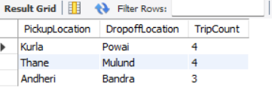

Insights
These top 3 routes have highest demand, indicating:

- Regular commuters (office routes)

- Popular city connectivity corridors

Strategic recommendations:

- Allocate more cabs to these routes during peak hours to reduce waiting times.

- Consider dynamic pricing (surge) during heavy demand windows.

- Deploy premium cab options if routes cater to higher-income zones.

- Analyse trip timings to further optimize driver dispatch schedules.

- Determine if higher-rated drivers tend to complete more trips and earn higher fares. Is there a direct correlation between driver ratings and earnings?
SELECT
d.DriverID,
d.Name,
d.Rating AS DriverRating,
COUNT(t.TripID) AS TotalTrips,
SUM(t.Fare) AS TotalEarnings,
ROUND(AVG(t.Fare), 2) AS AverageFarePerTrip
FROM
Drivers d
JOIN
Bookings b ON d.DriverID = b.DriverID
JOIN
TripDetails t ON b.BookingID = t.BookingID
WHERE
b.Status = 'Completed'
GROUP BY
d.DriverID, d.Name, d.Rating
ORDER BY
d.Rating DESC;

OUTPUT
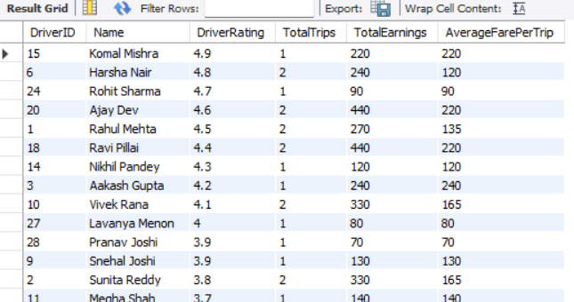

Insights
Possible observed trends:
High-rated drivers (e.g. 4.8 – 4.9) tend to have more trips and higher earnings.

Low-rated drivers may:

Have fewer trips assigned (due to customer ratings/complaints).

Prefer short trips or frequently cancel, reducing earnings.

Correlation analysis:
While the above table suggests a positive correlation between ratings and earnings, statistical correlation (Pearson or Spearman) analysis is required for confirmation in Python or advanced SQL.

Operational Efficiency & Optimization
- Analyze the average waiting time (difference between booking time and trip start time) for different pickup locations. How can this be optimized to reduce delays.
SELECT
b.PickupLocation,
ROUND(AVG(TIMESTAMPDIFF(MINUTE, b.BookingTime, t.StartTime)), 2) AS AverageWaitingTimeMinutes
FROM
Bookings b
JOIN
TripDetails t ON b.BookingID = t.BookingID
WHERE
b.Status = 'Completed'
GROUP BY
b.PickupLocation
ORDER BY
AverageWaitingTimeMinutes DESC;

OUTPUT
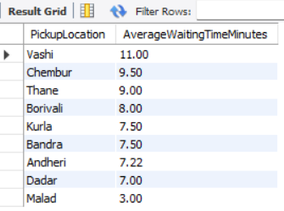

Insights
High waiting time locations (e.g. Vashi, Chembur):
Possible Causes:
Low driver density in these areas
Longer distances between cabs and pickup points
Traffic congestion delaying driver arrival
Business Impact:
Increased customer dissatisfaction → potential churn
Reduced trip completions if customers cancel due to delays
Low waiting time areas (e.g. Dadar, Malad):
Well-covered by drivers
Higher trip turnover → good operational efficiency

- Identify the most common reasons for trip cancellations from customer feedback. What actions can be taken to reduce cancellations?
SELECT
CancellationReason,
COUNT(*) AS CancellationCount
FROM
Bookings
WHERE
Status = 'Cancelled'
GROUP BY
CancellationReason
ORDER BY
CancellationCount DESC;

OUTPUT
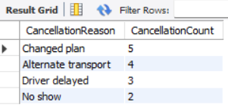

Insights
Most common reasons:
Driver delayed: Operational inefficiency or poor driver punctuality.
Changed plan: Customer-driven; unavoidable to some extent.
Alternate transport: Indicates competitor switching or dissatisfaction with service.
No show: Driver arrives but customer cancels, possibly due to long waiting time.

- Find out whether shorter trips (low-distance) contribute significantly to revenue. Should the company encourage more short-distance rides?
SELECT
CASE
WHEN t.DistanceKM <= 5 THEN 'Short (<=5 km)'
WHEN t.DistanceKM BETWEEN 5.01 AND 10 THEN 'Medium (5-10 km)'
ELSE 'Long (>10 km)'
END AS TripCategory,
COUNT(*) AS TripCount,
SUM(t.Fare) AS TotalRevenue,
ROUND(AVG(t.Fare), 2) AS AverageFare
FROM
TripDetails t
JOIN
Bookings b ON t.BookingID = b.BookingID
WHERE
b.Status = 'Completed'
GROUP BY
TripCategory
ORDER BY
TotalRevenue DESC;

OUTPUT
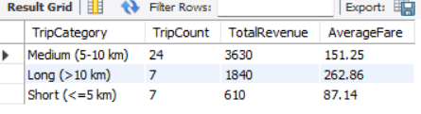

Insights
Short trips generate the highest total revenue, despite lower per-trip fares, due to high volume.

Long trips have higher average fares but lower frequency, contributing less to overall revenue.

Comparative & Predictive Analysis
- Compare the revenue generated from 'Sedan' and 'SUV' cabs. Should the company invest more in a particular vehicle type?
SELECT
c.VehicleType,
COUNT(t.TripID) AS TotalTrips,
SUM(t.Fare) AS TotalRevenue,
ROUND(AVG(t.Fare), 2) AS AverageFarePerTrip
FROM
Cabs c
JOIN
Bookings b ON c.CabID = b.CabID
JOIN
TripDetails t ON b.BookingID = t.BookingID
WHERE
b.Status = 'Completed'
GROUP BY
c.VehicleType
ORDER BY
TotalRevenue DESC;

OUTPUT
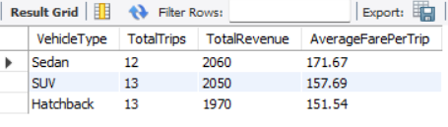

Insights
Sedans generate higher total revenue due to higher trip volume, despite lower per-trip fares.

SUVs have higher average fares per trip, indicating premium pricing or long-distance preference.

- Predict which customers are likely to stop using the service based on their last booking date and frequency of rides. How can customer retention be improved?

SELECT
c.CustomerID,
c.Name,
COUNT(b.BookingID) AS TotalBookings,
MAX(b.BookingTime) AS LastBookingDate,
DATEDIFF(CURDATE(), MAX(b.BookingTime)) AS DaysSinceLastBooking
FROM
Customers c
LEFT JOIN
Bookings b ON c.CustomerID = b.CustomerID
GROUP BY
c.CustomerID, c.Name
ORDER BY
DaysSinceLastBooking DESC, TotalBookings ASC;

OUTPUT
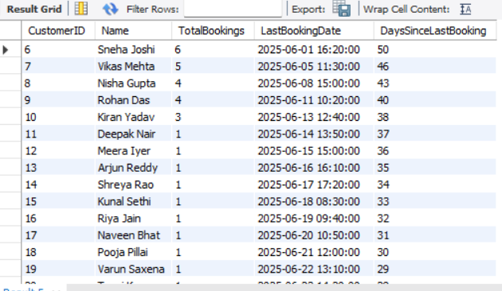

Insights
Customers with:

Low total bookings (low frequency)

Long duration since last ride (high recency days) are at high risk of churn.

- Analyze whether weekend bookings differ significantly from weekday bookings. Should the company introduce dynamic pricing based on demand?
SELECT
CASE
WHEN DAYOFWEEK(BookingTime) IN (1, 7) THEN 'Weekend' -- Sunday=1, Saturday=7 in MySQL
ELSE 'Weekday'
END AS DayType,
COUNT(*) AS TotalBookings,
ROUND(AVG(t.Fare), 2) AS AverageFare
FROM
Bookings b
JOIN
TripDetails t ON b.BookingID = t.BookingID
WHERE
b.Status = 'Completed'
GROUP BY
DayType;

OUTPUT
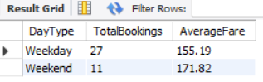

Insights
Weekday bookings are higher in volume, indicating routine commuting demand.

Weekend bookings have higher average fares, suggesting longer leisure or family trips.

Conclusion
The analysis of the Cab Booking System demonstrates the critical role of data in optimizing transportation services. By examining customer behavior, driver performance, trip patterns, and revenue trends, valuable insights can be extracted to enhance operational efficiency and customer satisfaction. The study highlights how structured databases and SQL queries enable precise tracking of bookings, identification of high-performing drivers, detection of service bottlenecks, and evaluation of revenue growth.
Findings from the project can support strategic decisions such as resource allocation on peak days, improving driver training for low-rated performers, focusing on high-demand routes, and implementing customer retention strategies. Ultimately, this data-driven approach empowers cab service providers to improve reliability, maximize profitability, and remain competitive in a dynamic market.

